Machine Learning Homework2

**Question 1.**

1. The answer is show as the picture below

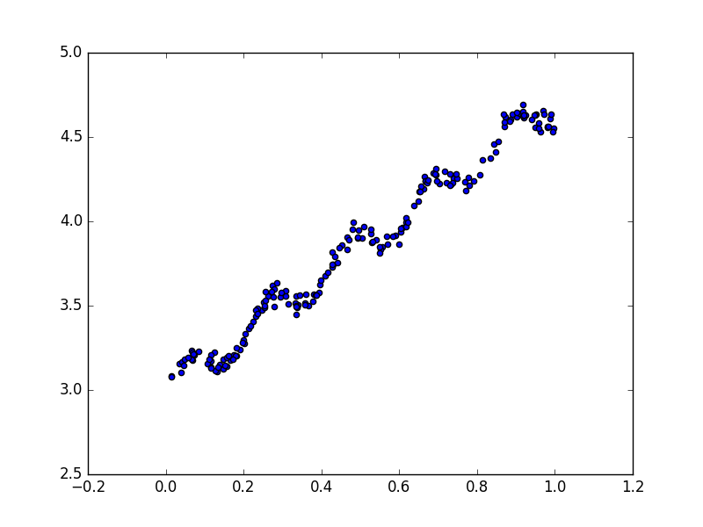

1. The answer is show as the picture below

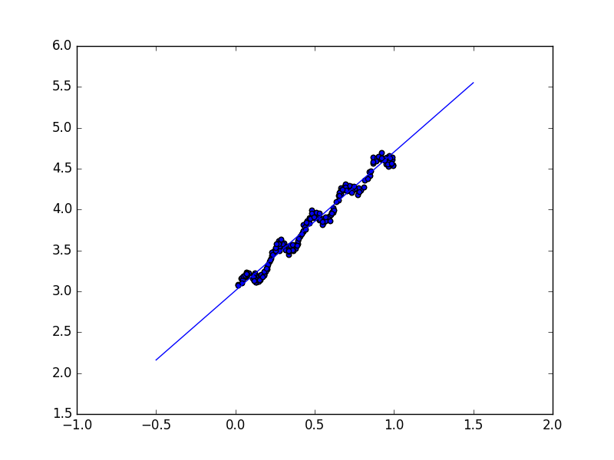

We have a two dimensional coefficient, theta, which equals to

**{ 3.00774324, 1.69532264}**

1. The answer is show as the picture below

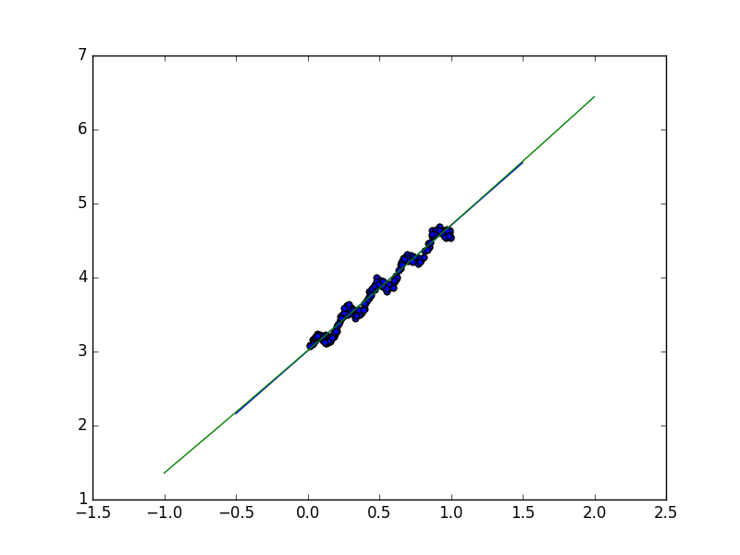

In this figure, I draw two lines. The green one represent the polynomial regression and the blue one represent the linear regression. In this range of data, these two lines are similar.

And we have a three dimensional coefficient, theta, which equals to

**{ 3.01139245, 1.67414864, 0.02065965}**

**Question 2.**

* 1. The answer is show as the picture below

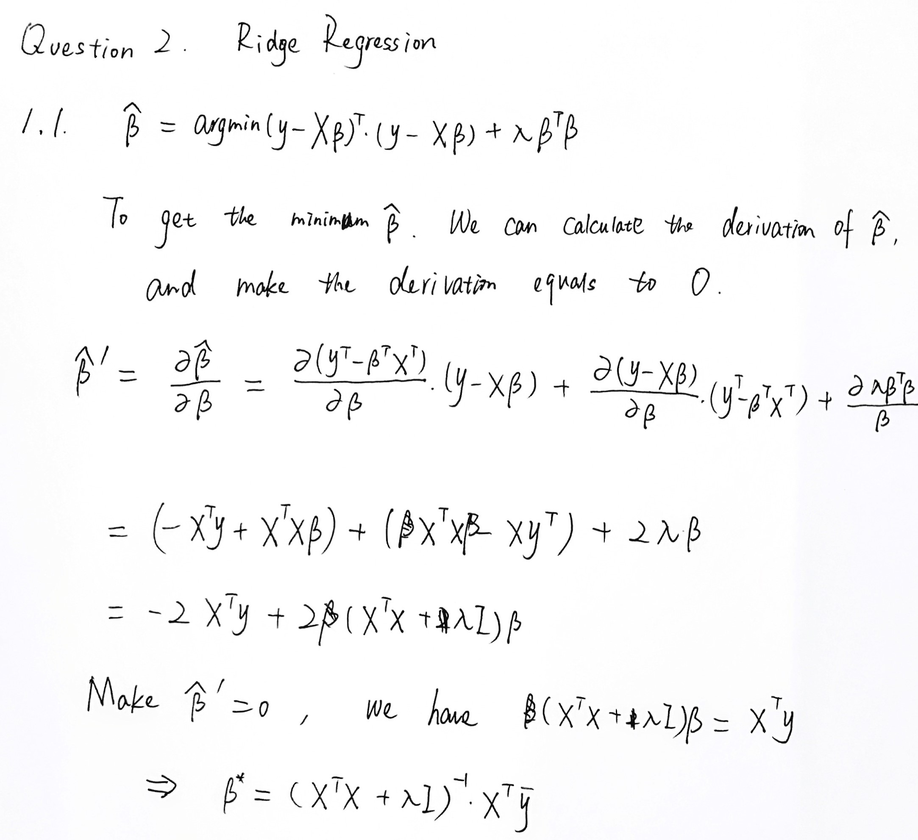

* 1. In this case, the X matrix is not a full rank matrix, which means it is not inversable, so it cannot be solved through linear regression.
  2. The coefficient β is sparse, which means there is at least one zero row vector. So we can use Lasso regression. As Lasso will set some of the small coefficients to zero, which means the zero row vector will not influence and interrupt the regression process.
     1. The answer is show as the picture below:

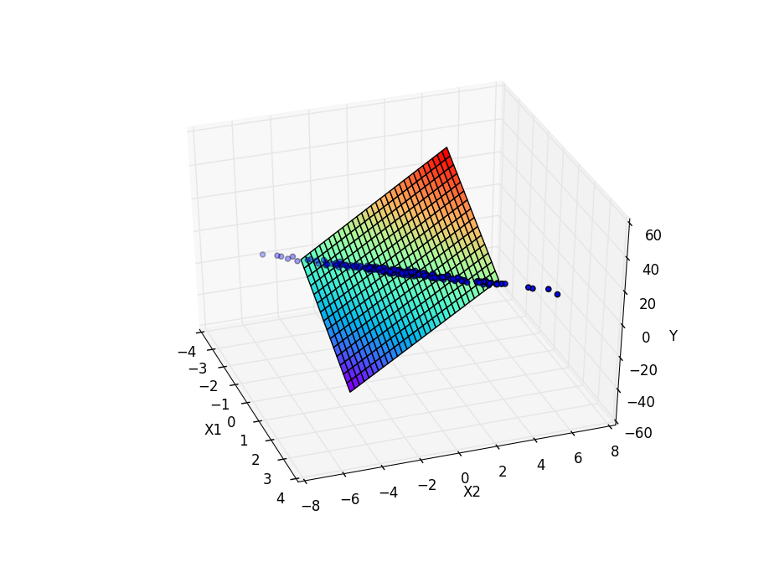

And we have calculated theta = { 2.97139801, -11.00332214, 6.96229098}

1.4.2